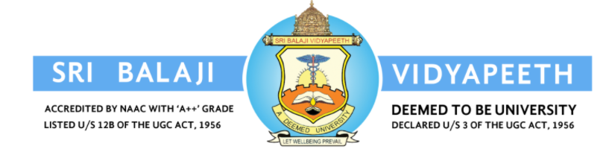

APPLICATION FOR REQUESTING PRIOR PERMISSION TO ATTEND THE CONFERENCE
Date:
- Name of the Faculty (Phone & Mail address):
- Designation :
- Department :
- Institution :

- Date & No. of days of conference :
(Proof to be attached)

- Place &Details of conference:
(National/International/State or other) :
(Proof to be attached)

- Expenditure to be involved:
(Delegation fee/Travelling expenses) :

Signature of the Faculty
Encl:
1) Brochure
2) Usefulness Certificate from HOD/Principal
3) Abstract-Acceptance
4) Invitation of Guest Lecture/Resource Person
5) Details of tickets booked
6) Acknowledgement of SBV
7) Abstract of Presentation

Heads of Department Dean/Principal VP(R,I &D)

