TRANSCRIPT

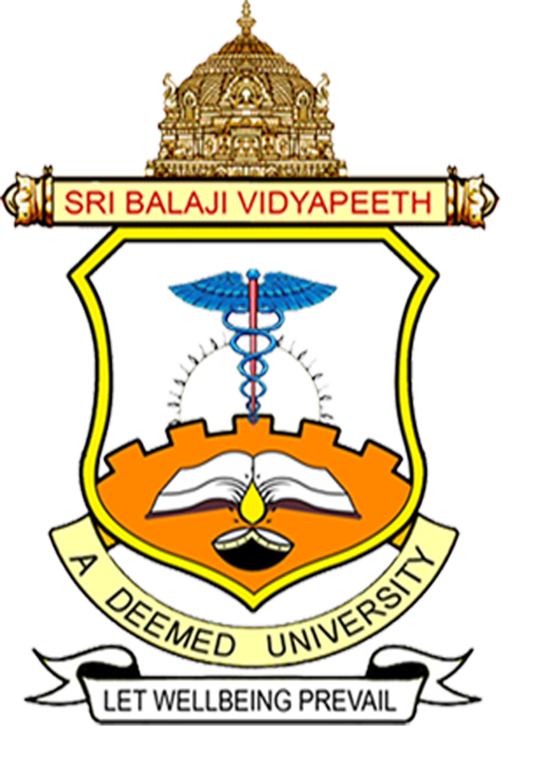

Theme: EYE DONATION
Name : DR SRIKANTH K
Designation : PROFESSOR & HOD
Department of Ophthalmology
MGMCRI
University : SRI BALAJI VIDYAPEETH UNIVERSITY
Place :PONDICHERRY
TRANSCRIPT
EYE DONATION

INTRODUCTION:
As Shakespeare rightly said "Eyes are indeed the windows to our soul"
Eye sight is the most precious among all the senses and impairment of vision is considered to be the most profound disability.
Blindness Is one of the major public health problems in the developing countries.
According to WHO corneal diseases are among the major causes of vision loss and blindness can be tackled with corneal transplantation / Keratoplasty which is dependent on "voluntary donation of the eyes in the event of previous death"

EYE DONATION
Donating eyes after death, a corneal blind person can see again through a surgical procedure known as corneal transplantation where the damaged cornea is replaced by a healthy cornea from eye donor.
It is of immense concern that almost half of the world blind population reside in India and most of these are reversible.
- Those of us who wish for eyes to be used after we die can pledge them while we are alive.
- Pledging eyes is a noble act which ensures that your eyes continue to help someone else sees the world, even after death.
- It is an altruistic act purely voluntary and perhaps the greatest charity of all.
- People of all ages and genders can donate their cornea.
- Use of spectacles or even those operated for cataract is not a contraindication
- Patients who have diabetes, suffering from Hypertension, Asthma and those without communicable diseases can donate.
- Person who donates eye can provide the gift of sight to 2 blind people.
- There are numerous reasons as to why people do not donate their eyes - Lack of awareness among the public is one.
CONCLUSION
All the eyes donated to eye bank are used and a record is maintained, those eyes not suitable for corneal transplant are used for medical research and education.

