TRANSCRIPT

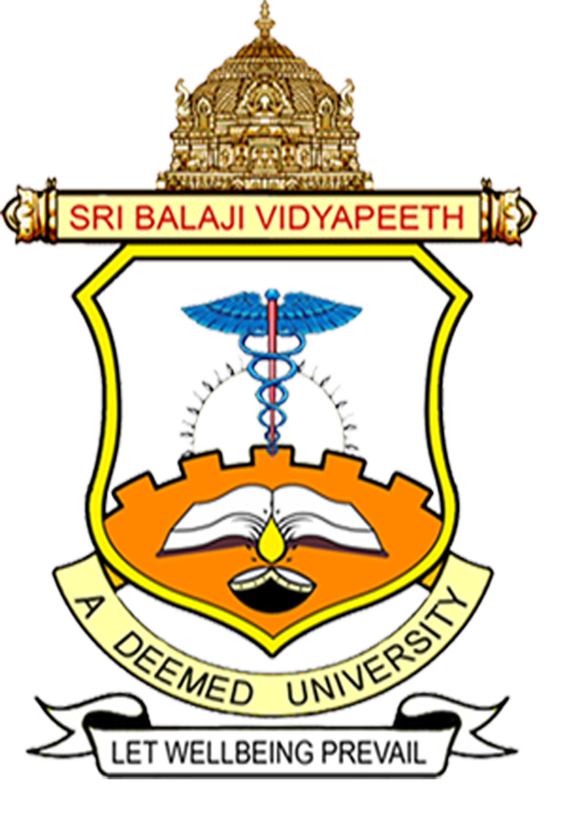

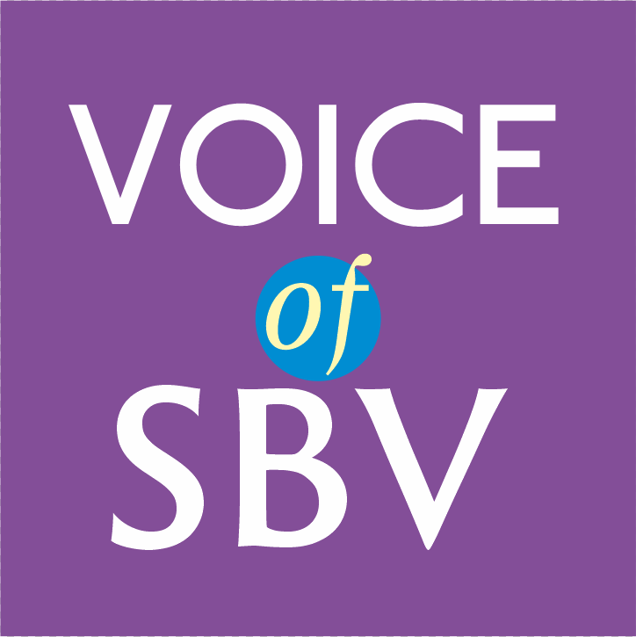

Theme: WOMEN EMPOWERMENT
Name : PROF SUBHASH CHANDRA PARIJA
Designation : VICE CHANCELLOR
College
University : SRI BLAJI VIDYAPEETH UNIVERSITY
Place :PONDICHERRY
TRANSCRIPT
The Global Landscape of WOMEN EMPOWERMENT

INTRODUCTION
Acquiring knowledge and understanding the essentials of gender relations play a vital role and women need to develop a sense of self-worthiness, belief in one's ability to accomplish desired changes. Securing the right to control one's life should receive utmost priority.
The history of women's empowerment in the ancient age is mixed, because on one side it encouraged women to choose their life partners on their own and on the other hand they were forced to perform a ritual such as sati, as per social norms. The first ever social network for women was created in ancient age, and it was known as the "Bhikkuni Sangh". It was created by the "Enlightened Buddha".
HISTORY
It was in the year 1848 that India got its first woman educator in the form of "Savitribai Phule". This year marks the rise of women empowerment in India as Savitribai Phule busted the social norm that a woman cannot be educated. The impact of this movement was so profound that 100 years later, India, as a nation accepted the leadership of a woman and Indira Gandhi, was sworn in as the first woman prime minister of India. Kalpana Chawla became the first Indian woman to travel in space. All these activities depict women empowerment.
Well, women empowerment as a concept was introduced at the United Nations Third World Conference on Women in Nairobi in 1985, which defined it as a control of resources in favor of women. The United Nations Development Fund for Women (UNDFW) includes various factors in its definition of women empowerment.

WOMEN EMPOWERMENT
Following various revolutions and social reforms during the modern era, the condition of Women has vastly improved and women are now redefined by their strengths, skills and intrinsic abilities. Today, the woman is synonymous with a pilot, a doctor, an engineer, a politician, an artist, an author, a leader, a president and much more; she is a homemaker and a complete administrator.
Women empowerment has now become an international agenda. The United Nations' charter significantly projected discrimination against woman as a problem of universal alarm. This shows the kind of concern of international community with regard to women's rights in general and their right to equality with men, in particular.

WHAT IS WOMEN EMPOWERMENT?
Women empowerment can be defined as a cause for promoting women’s sense of self-worthiness, ability to determine their own choices, and their right to influence social change for themselves and others. It is closely aligned with female empowerment – a basic human right that’s also considered pivotal in achieving a more peaceful and prosperous world.
Women empowerment and promoting women’s rights have emerged as a greater part of a major global movement and is continuing to expand its horizons in recent years. Commemorative days such as International Women’s Day are also gaining momentum. Having said that, I also have to caution the listeners that women and girls continue to face discrimination and violence in every part of the world.

THE WOMEN'S EMPOWERMENT PRINCIPLES
United Nations Women’s Empowerment Principles are used to empower women.

The seven Principles are:
- Principle 1: Create high-level corporate leadership for gender equality
- Principle 2: Treat all people fairly at work, respecting and supporting non-discrimination and human rights
- Principle 3: Ensure the health, wellbeing and safety of all workers, whether male or female
- Principle 4: Promote education, training and professional development for women
- Principle 5: Implement supply chain, marketing practices and enterprise development that empower women
- Principle 6: Champion equality through community initiatives and advocacy
- Principle 7: Measure and report publicly on progress to create gender equality

WHY IS EMPOWERING GIRLS AND WOMEN SO IMPORTANT?
Empowering women is essential to the health and social development of families, communities and countries.
The principles of gender equality, equal rights are enshrined in the Indian constitution in its preamble, fundamental rights, fundamental duties and directive principles. The Constitution not only grants equality to women but also have empowered the state to adopt a positive attitude in favor of women.
The government of India declared 2001 as the Year of Women Empowerment (Swashakti). The national policy for the empowerment of women was passed in 2001. The objective of this policy is aimed at the provision of human rights and fundamental freedom to women on equal basis with men in all spheres -- political, economic, social, cultural and civil.

HOW CAN WE EMPOWER WOMEN AND GIRLS?
There are several activities one can get involved in order to support the rights of women in developing countries such as India,
- Sponsor a girl: When you sponsor a girl, you can give her the tools to gain education and give back the rights she deserves. This is a key way that girls can be empowered to grow up and influence their generation – and the next.
- Educate yourself by finding out about issues that affect girls – for instance, child marriage.
- Helping girls and women learn advocacy skills at all stages of life so that they can use their voices effectively for their own rights
- Partnering with communities, faith leaders and governments to challenge and correct harmful social norms that keep women and girls from revealing their true potentials
- Raising awareness around the causes of poor health and wellbeing that are related to gender
- Empowering women and girls through water, sanitation and hygiene; health and nutrition; livelihood training; and education programs to increase their opportunities and ability to reach their full potential
WOMEN EMPOWERMENT IN AN ERA OF SOCIAL DISTANCING
The COVID-19-fueled economic crisis has made vulnerable women workers even more exposed to job insecurity and diminished protections of worker rights. Workers have been facing increased reliance on credit, notable escalation in violence at home and at the workplace, and reduced health-seeking tendencies due to concerns around COVID-19. Such challenges are indeed formidable and can seem especially difficult to tackle in terms of social distancing and restrictions on movement that reduce access to local services and support.
At the onset of the crisis, factories have halted production for long periods, and when they were finally able to reopen, they did so with limited capacity given. Furthermore, there are still budget cuts and adaptations for social distancing.
BRIDGING THE GAP
A gender divide currently exists in digital literacy and access. However, closing the digital gender gap has immense potentials to reduce inequalities and empower women. By increasing workers’ skills and versatility in the workforce, in addition to providing access to key information, digital tools have the potential to strengthen women’s awareness and capacity.
Digital tools is not merely the remedy to women workers’ vulnerabilities in global supply chains, but they can have an impact on empowering women with information and skills to strengthen their fortitude especially in times where traditional methods are restricted. Digital implementations have begun in factories in several countries including India, Pakistan, Costa Rica, Honduras, Myanmar, Cambodia, Kenya, and Ethiopia. While there is much more to understand in the realms of digital learning this is a positive step toward putting tools and resources in the hands of women workers.
CONCLUSION
Higher education is appropriately regarded as the portal to economic independence, social equity and opportunities for career women in India. Ever since the last two decades, Indian women have been playing a key role in Knowledge dissemination, Governance and that is vividly envisaged in the broad policies of the Government of India.
The Indian Government has introduced several cardinal policies synonymous with gender equity. Besides, higher education for women in India has witnessed a historic and impressive growth over the years.
Women Empowerment at higher education institutions assumes great relevance at Indian Universities, thanks to the directives of the Ministry of Social Welfare and Ministry of Education. Adopting an environment, wherein women occupy top positions in academics and administration would augur well for the nation. Pradhan Mantri Mudra Yojana, and Sukanya Samriddhi Yojana are some of the schemes elaborated by the Government of India that vividly depict women empowerment at the national level. Sri Balaji Vidyapeeth, popularly referred to as SBV has taken cognizance of women empowerment and implements the same in letter, spirit and action. This has already manifested in the form of top women administrators who don an active role in the overall growth and development of SBV, in the frontiers of education, research and patient care.
“Being A Woman Should Be Your Supreme Achievement And Not Your Deepest Fear. Celebrate Womanhood, Fuel Yourself With Self-Confidence And Let That Fuel Empower You To Soar Towards Your Dreams.”

References:

